**LUCKNOW PUBLIC SCHOOL**

(C. P. SINGH FOUNDATION)



**Project Report**

Informatics Practices (065)

(Session: 2022-23)

Student Name : Manas Rai

Class : XII

Section : A  
Roll No. :

***CERTIFICATE***

This is to certify that this work is submitted by **Manas Rai**

To the Informatics Practices Department of **LUCKNPW PUBLIC SCHOOL Sector - F Jankipuram Lucknow** and was carried out under the supervision and guidance of Head of Informatics Practices **Mr. Abhay Pratap Singh** during the **Session 2022-2023**

**Date Teacher In Charge**

**Principal Examiner**

***ACKNOWLEDGEMENT***

I take this opportunity with great pleasure and respect to express my first and foremost thanks to the principal, ‘’***Mrs. Sushmita Sarkar***’’ for her encouragement and for the facilities that she provided for this project work . I extend my hearty thanks to ‘’***Mr. Abhay Pratap Singh***’’, Informatics Practices Teacher who guided me throughout the successful completion of the project . I take this opportunity to express my deep sense of gratitude for his guidance, constant encouragement, immense motivation, which has sustained my efforts at all the stages of this project.

I can’t forget to offer my sincere thanks to the parents and to also my classmates who helped me to carry out this project work successfully and for their valuable advice and support, which I received from time to time.

***CONTENT***

* ***INTRODUCTION***
* ***SOFTWARE $ HAREWARE REQUIREMENT***
* ***SOURCE CODE IN PYTHON***
* ***OUTPUT SCREEN***
* ***BIBLIOGRAPHY***

***INTRODUCTION***

**Restaurant billing system** is the profession of managinga restaurant billing. It includes the major function of planning, organizing; efficientlyand effectively plan menus at profitable prices. This system will help to manage the restaurant billing system systematically; we will provide software that can be used by the cashier. This is a software package to facilitate ordering within a restaurant. The customer is able to view the menu in an electronic gadget and organize a bill through that electronic gadget.

**The project provides facilities function like :**

* It helps the restaurant manager to manage the restaurant more efficiently and effectively by computerizing Meal Ordering, billing and many more things.
* It Increases the Security.
* It avoids Paper work

***SOWTWARE AND HARDWARE REQUIREMENT***

***Software Specification :-***

***Operating System:*** *Windows 10/8/7*

***Plateform:*** *Python IDLE 3.8 or above*

***Languages:*** *Python*

***Hardware specifation:-***

***Processor:*** *Dual Core Or above*

***Hard Disk: 40*** *GB*

***RAM: 1025****MB*

**Note:-**

Please install the following libraries before running the programs:

* Numpy
* Pandas

***SOURCE CODE***

import pandas as pd

def CR():

print('\n By Manash rai')

print('\n Thank you for visiting us ')

def veg_nonveg():

df=pd.read_csv('D:\\ip project\\resturant billing system\\veg_non.csv',index_col='Keys')

print(df)

def menu1():

df1=pd.read_csv('D:\\ip project\\resturant billing system\\menu1.csv',index_col='Keys')

print(df1)

def menu11():

df2=pd.read_csv('D:\\ip project\\resturant billing system\\menu11.csv',index_col='Keys')

print(df2)

def menuVB():

df3=pd.read_csv('D:\\ip project\\resturant billing system\\menuVB.csv',index_col='Keys')

print(df3)

def menuNB():

df4=pd.read_csv('D:\\ip project\\resturant billing system\\menuNB.csv',index_col='Keys')

print(df4)

def menuVP():

df5=pd.read_csv('D:\\ip project\\resturant billing system\\menuVP.csv',index_col='Keys')

print(df5)

def menuNP():

df6=pd.read_csv('D:\\ip project\\resturant billing system\\menuNP.csv',index_col='Keys')

print(df6)

def menuVM():

df7=pd.read_csv('D:\\ip project\\resturant billing system\\menuVM.csv',index_col='Keys')

print(df7)

def menuNM():

df8=pd.read_csv('D:\\ip project\\resturant billing system\\menuNM.csv',index_col='Keys')

print(df8)

def menuVC():

df9=pd.read_csv('D:\\ip project\\resturant billing system\\menuVC.csv',index_col='Keys')

print(df9)

def menuNC():

df10=pd.read_csv('D:\\ip project\\resturant billing system\\menuNC.csv',index_col='Keys')

print(df10)

def menuVS():

df11=pd.read_csv('D:\\ip project\\resturant billing system\\menuVS.csv',index_col='Keys')

print(df11)

def menuNS():

df12=pd.read_csv('D:\\ip project\\resturant billing system\\menuNS.csv',index_col='Keys')

print(df12)

def menu12():

df13=pd.read_csv('D:\\ip project\\resturant billing system\\menu12.csv',index_col='Keys')

print(df13)

def menuSV():

df14=pd.read_csv('D:\\ip project\\resturant billing system\\menuSV.csv',index_col='Keys')

print(df14)

def menuSN():

df15=pd.read_csv('D:\\ip project\\resturant billing system\\menuSN.csv',index_col='Keys')

print(df15)

def menuSl():

df6=pd.read_csv('D:\\ip project\\resturant billing system\\menuSl.csv',index_col='Keys')

print(df6)

def menuR():

df16=pd.read_csv('D:\\ip project\\resturant billing system\\menuR.csv',index_col='Keys')

print(df16)

def menuVMa():

df17=pd.read_csv('D:\\ip project\\resturant billing system\\menuVMa.csv',index_col='Keys')

print(df17)

def menuNMa():

df18=pd.read_csv('D:\\ip project\\resturant billing system\\menuNMa.csv',index_col='Keys')

print(df18)

def menuRo():

df19=pd.read_csv('D:\\ip project\\resturant billing system\\menuRo.csv',index_col='Keys')

print(df19)

def menu13():

df20=pd.read_csv('D:\\ip project\\resturant billing system\\menu13.csv',index_col='Keys')

print(df20)

def menuC():

df21=pd.read_csv('D:\\ip project\\resturant billing system\\menuC.csv',index_col='Keys')

print(df21)

def menuI():

df22=pd.read_csv('D:\\ip project\\resturant billing system\\menuI.csv',index_col='Keys')

print(df22)

def menuIS():

df23=pd.read_csv('D:\\ip project\\resturant billing system\\menuIS.csv',index_col='Keys')

print(df23)

def welcome():

print(' ')

print('#','::::::::::::::::::::::::'*3,'#')

print('#','::::::::::'*3, (' ')*1, (' ')*7, '::::::::'*3,'#')

print('#',':::::::::'*3, 'Restaurant', '::::::::::'*3,'#')

print('#','::::::::::'*3, (' ')*1, (' ')*7, '::::::::'*3,'#')

print('#','::::::::::::::::::::::::'*3,'#')

print(' ')

print(' ')

print(' '*15, 'Hello Sir/Madam, Have A Good Day Ahead')

print(' ')

print(' ')

print(' '*3,'::::>>>>>'*3,'Menu','<<<<<::::'*3)

print(' ')

print(' ')

def separator():

print('--------------------------------------------------------------------------')

def separator1():

print('__________________________________________________________________________')

welcome()

cost = 0

n = []

o = []

p = []

a = 1

while a == 1:

a=a-1

separator()

menu1()

separator1()

c = input('what would you like to have , Sir ')

r2=1

while r2==1:

r2=r2-1

if c == '1':

separator()

menu11()

separator1()

b = input('what would you like to have , Sir ')

if b == '1':

r=1

while r==1:

separator()

veg_nonveg()

separator1()

e = input('what would you prefer , Sir (use capital letters )')

if e == 'V':

separator()

menuVB()

separator1()

f = input('what would you like to have , Sir (use capital letters )')

if f == 'E':

g = int(input('How many would you like to have:'))

n.append('Blackbean Burger ')

o.append(g)

p.append(80)

h = g * 80

print('Total price :', h)

cost = cost + h

m = int(input('do you want somethink else 0-no/1-yes'))

r=m

a=1

elif f == 'F':

g = int(input('How many would you like to have:'))

n.append('Falafel Burger ')

o.append(g)

p.append(90)

h = g * 90

print('Total price :', h)

cost = cost + h

m = int(input('do you want somethink else 0-no/1-yes'))

r=m

a=1

elif f == 'Q':

g = int(input('How many would you like to have:'))

n.append('Quinoa Veggies Burger ')

o.append(g)

p.append(100)

h = g * 100

print('Total price :', h)

cost = cost + h

m = int(input('do you want somethink else 0-no/1-yes'))

r=m

a=1

elif f == 'A':

g = int(input('How many would you like to have:'))

n.append('Aloo Tikki Burger ')

o.append(g)

p.append(120)

h = g * 120

print('Total price :', h)

cost = cost + h

m = int(input('do you want somethink else 0-no/1-yes'))

r=m

a=1

elif f == 'T':

g = int(input('How many would you like to have:'))

n.append('Tofu Burger ')

o.append(g)

p.append(130)

h = g * 130

print('Total price :', h)

cost = cost + h

m = int(input('do you want somethink else 0-no/1-yes'))

r=m

a=1

elif f== 'B':

pass

r==1

a==1

else:

print('INVALID ENTRY ')

elif e == 'N':

separator()

menuNB()

separator1()

f = input('what would you like to have , Sir (use capital letters )')

if f == 'P':

g = int(input('How many would you like to have:'))

n.append('Chill Burger with Pepper Relish ')

o.append(g)

p.append(130)

h = g * 130

print('Total price :', h)

cost = cost + h

m = int(int(input('do you want somethink else 0-no/1-yes')))

r=m

a=1

elif f == 'C':

g = int(input('How many would you like to have:'))

n.append('Chicken Burger')

o.append(g)

p.append(140)

h = g * 140

print('Total price :', h)

cost = cost + h

m = int(input('do you want somethink else 0-no/1-yes'))

r=m

a=1

elif f == 'F':

g = int(input('How many would you like to have:'))

n.append('Fish and Chicken Burger ')

o.append(g)

p.append(150)

h = g * 150

print('Total price :', h)

cost = cost + h

m = int(input('do you want somethink else 0-no/1-yes'))

r=m

a=1

elif f == 'Q':

g = int(input('How many would you like to have:'))

n.append('Butter Chicken Burger ')

o.append(g)

p.append(160)

h = g * 160

print('Total price :', h)

cost = cost + h

m = int(input('do you want somethink else 0-no/1-yes'))

r=m

a=1

elif f == 'D':

g = int(input('How many would you like to have:'))

n.append('Double Chicken Burger ')

o.append(g)

p.append(170)

h = g * 170

print('Total price :', h)

cost = cost + h

m = int(input('do you want somethink else 0-no/1-yes'))

r=m

a=1

elif f=='B':

pass

r=1

a=1

else:

print('INVALID ENTRY ')

elif e=='B':

pass

r2=1

r=1

a=0

else:

print('INVALID ENTRY ')

if b == '2':

r=1

while r==1:

separator()

veg_nonveg()

separator1()

e = input('what would you prefer , Sir (use capital letters )')

if e == 'V':

separator()

menuVP()

separator1()

f = input('what would you like to have , Sir (use capital letters )')

if f == 'P':

g = int(input('How many would you like to have:'))

n.append('Panner Special Pizza ')

o.append(g)

p.append(280)

h = g * 280

print('Total price :', h)

cost = cost + h

m = int(input('do you want somethink else 0-no/1-yes'))

r=m

a=1

elif f == 'T':

g = int(input('How many would you like to have:'))

n.append('Taco Style Pizza ')

o.append(g)

p.append(290)

h = g * 290

print('Total price :', h)

cost = cost + h

m = int(input('do you want somethink else 0-no/1-yes'))

r=m

a=1

elif f == 'M':

g = int(input('How many would you like to have:'))

n.append('Mediterraner Special Pizza ')

o.append(g)

p.append(300)

h = g * 300

print('Total price :', h)

cost = cost + h

m = int(input('do you want somethink else 0-no/1-yes'))

r=m

a=1

elif f == 'F':

g = int(input('How many would you like to have:'))

n.append('Four Cheese Pizza ')

o.append(g)

p.append(320)

h = g * 320

print('Total price :', h)

cost = cost + h

m = int(input('do you want somethink else 0-no/1-yes'))

r=m

a=1

elif f == 'C':

g = int(input('How many would you like to have:'))

n.append('Capsicum Pizza ')

o.append(g)

p.append(330)

h = g * 330

print('Total price :', h)

cost = cost + h

m = int(input('do you want somethink else 0-no/1-yes'))

r=m

a=1

elif f=='B':

pass

r=1

a=1

else:

print('INVALID ENTRY ')

elif e == 'N':

separator()

menuNP()

separator1()

f = input('what would you like to have , Sir (use capital letters )')

if f == 'E':

g = int(input('How many would you like to have:'))

n.append('Barbeque Chicken Pizza')

o.append(g)

p.append(230)

h = g * 230

print('Total price :', h)

cost = cost + h

m = int(input('do you want somethink else 0-no/1-yes'))

r=m

a=1

elif f == 'C':

g = int(input('How many would you like to have:'))

n.append('CLassic Chicken Pizza ')

o.append(g)

p.append(240)

h = g * 240

print('Total price :', h)

cost = cost + h

m = int(input('do you want somethink else 0-no/1-yes'))

r=m

a=1

elif f == 'M':

g = int(input('How many would you like to have:'))

n.append('Chicken Mexican Pizza ')

o.append(g)

p.append(250)

h = g * 250

print('Total price :', h)

cost = cost + h

m = int(input('do you want somethink else 0-no/1-yes'))

r=m

a=1

elif f == 'P':

g = int(input('How many would you like to have:'))

n.append('Pepperoni Pizza ')

o.append(g)

p.append(260)

h = g * 260

print('Total price :', h)

cost = cost + h

m = int(input('do you want somethink else 0-no/1-yes'))

r=m

a=1

elif f == 'H':

g = int(input('How many would you like to have:'))

n.append('Hot N Spicy Chicken Pizza ')

o.append(g)

p.append(270)

h = g * 270

print('Total price :', h)

cost = cost + h

m = int(input('do you want somethink else 0-no/1-yes'))

r=m

a=1

elif f=='B':

pass

r=1

a=1

else:

print('INVALID ENTRY ')

else:

print('INVALID ENTRY ')

if b == '3':

r=1

while r==1:

separator()

veg_nonveg()

separator1()

e = input('what would you prefer , Sir (use capital letters )')

if e == 'V':

menuVM()

f = input('what would you like to have , Sir (use capital letters )')

if f == 'S':

g = int(input('How many would plates you like to have:'))

n.append('Steamed Veg Momos ')

o.append(g)

p.append(80)

h = g * 80

print('Total price :', h)

cost = cost + h

m = int(input('do you want somethink else 0-no/1-yes'))

r=m

a=1

elif f == 'Y':

g = int(input('How many would plates you like to have:'))

n.append('Soya Momos ')

o.append(g)

p.append(90)

h = g * 90

print('Total price :', h)

cost = cost + h

m = int(input('do you want somethink else 0-no/1-yes'))

r=m

a=1

elif f == 'M':

g = int(input('How many would plates you like to have:'))

n.append('Mushroom Momos ')

o.append(g)

p.append(100)

h = g * 100

print('Total price :', h)

cost = cost + h

m = int(input('do you want somethink else 0-no/1-yes'))

r=m

a=1

elif f == 'F':

g = int(input('How many would plates you like to have:'))

n.append('Fried Momos ')

o.append(g)

p.append(120)

h = g * 120

print('Total price :', h)

cost = cost + h

m = int(input('do you want somethink else 0-no/1-yes'))

r=m

a=1

elif f == 'C':

g = int(input('How many would plates you like to have:'))

n.append('Cheese Momos ')

o.append(g)

p.append(130)

h = g * 130

print('Total price :', h)

cost = cost + h

m = int(input('do you want somethink else 0-no/1-yes'))

r=m

a=1

elif f=='B':

pass

r=1

a=1

else:

print('INVALID ENTRY ')

elif e == 'N':

separator()

menuNM()

separator1()

f = input('what would you like to have , Sir (use capital letters )')

if f == 'C':

g = int(input('How many would plates you like to have:'))

n.append('Steamed Chicken Momos ')

o.append(g)

p.append(130)

h = g * 130

print('Total price :', h)

cost = cost + h

m = int(input('do you want somethink else 0-no/1-yes'))

r=m

a=1

elif f == 'F':

g = int(input('How many would plates you like to have:'))

n.append('Fish Momos ')

o.append(g)

p.append(140)

h = g * 140

print('Total price :', h)

cost = cost + h

m = int(input('do you want somethink else 0-no/1-yes'))

r=m

a=1

elif f == 'P':

g = int(input('How many would plates you like to have:'))

n.append('Prawns Momos ')

o.append(g)

p.append(150)

h = g * 150

print('Total price :', h)

cost = cost + h

m = int(input('do you want somethink else 0-no/1-yes'))

r=m

a=1

elif f == 'S':

g = int(input('How many would plates you like to have:'))

n.append('Steamed Pork Momos ')

o.append(g)

p.append(160)

h = g * 160

print('Total price :', h)

cost = cost + h

m = int(input('do you want somethink else 0-no/1-yes'))

r=m

a=1

elif f == 'M':

g = int(input('How many would plates you like to have:'))

n.append('Meat Momos')

o.append(g)

p.append(170)

h = g * 170

print('Total price :', h)

cost = cost + h

m = int(input('do you want somethink else 0-no/1-yes'))

r=m

a=1

elif f=='B':

pass

r=1

a=1

else:

print('INVALID ENTRY ')

else:

print('INVALID ENTRY entery')

if b == '4':

r=1

while r==1:

separator()

veg_nonveg()

separator1()

e = input('what would you prefer , Sir (use capital letters )')

if e == 'V':

separator()

menuVC()

separator1()

f = input('what would you like to have , Sir (use capital letters )')

if f == 'W':

g = int(input('How many would plates you like to have:'))

n.append('White Chowmein ')

o.append(g)

p.append(80)

h = g * 80

print('Total price :', h)

cost = cost + h

m = int(input('do you want somethink else 0-no/1-yes'))

r=m

a=1

elif f == 'Y':

g = int(input('How many would plates you like to have:'))

n.append('Plain Chowmein')

o.append(g)

p.append(90)

h = g * 90

print('Total price :', h)

cost = cost + h

m = int(input('do you want somethink else 0-no/1-yes'))

r=m

a=1

elif f == 'M':

g = int(input('How many would plates you like to have:'))

n.append('Manchurian Chowmein ')

o.append(g)

p.append(100)

h = g * 100

print('Total price :', h)

cost = cost + h

m = int(input('do you want somethink else 0-no/1-yes'))

r=m

a=1

elif f == 'F':

g = int(input('How many would plates you like to have:'))

n.append('Paneer Chowmein ')

o.append(g)

p.append(120)

h = g * 120

print('Total price :', h)

cost = cost + h

m = int(input('do you want somethink else 0-no/1-yes'))

r=m

a=1

elif f == 'C':

g = int(input('How many would plates you like to have:'))

n.append('Crips Chowmein ')

o.append(g)

p.append(110)

h = g * 110

print('Total price :', h)

cost = cost + h

m = int(input('do you want somethink else 0-no/1-yes'))

r=m

a=1

elif f=='B':

pass

r=1

a=1

else:

print('INVALID ENTRY ')

elif e == 'N':

separator()

menuNC()

separator1()

f = input('what would you like to have , Sir (use capital letters )')

if f == 'C':

g = int(input('How many would plates you like to have:'))

n.append('Chicken Chowmein ')

o.append(g)

p.append(130)

h = g * 130

print('Total price :', h)

cost = cost + h

m = int(input('do you want somethink else 0-no/1-yes'))

r=m

a=1

elif f == 'P':

g = int(input('How many would plates you like to have:'))

n.append('Prawn Chowmein ')

o.append(g)

p.append(140)

h = g * 140

print('Total price :', h)

cost = cost + h

m = int(input('do you want somethink else 0-no/1-yes'))

r=m

a=1

elif f == 'R':

g = int(input('How many would plates you like to have:'))

n.append('Pork Chowmein ')

o.append(g)

p.append(150)

h = g * 150

print('Total price :', h)

cost = cost + h

m = int(input('do you want somethink else 0-no/1-yes'))

r=m

a=1

elif f == 'E':

g = int(input('How many would plates you like to have:'))

n.append('Egg Chowmein ')

o.append(g)

p.append(100)

h = g * 100

print('Total price :', h)

cost = cost + h

m = int(input('do you want somethink else 0-no/1-yes'))

r=m

a=1

elif f == 'H':

g = int(input('How many would plates you like to have:'))

n.append('Chicken Hakka Noodle')

o.append(g)

p.append(150)

h = g * 150

print('Total price :', h)

cost = cost + h

m = int(input('do you want somethink else 0-no/1-yes'))

r=m

elif f=='B':

pass

r=1

a=1

else:

print('INVALID ENTRY ')

else:

print('INVALID ENTRY entery')

if b == '5':

r=1

while r==1:

separator()

veg_nonveg()

separator1()

e = input('what would you prefer , Sir (use capital letters )')

if e == 'V':

separator()

menuVS()

separator()

f = input('what would you like to have , Sir (use capital letters )')

if f == 'M':

g = int(input('How many would plates you like to have:'))

n.append('Veg Mix Spring Roll ')

o.append(g)

p.append(80)

h = g * 80

print('Total price :', h)

cost = cost + h

m = int(input('do you want somethink else 0-no/1-yes'))

r=m

a=1

elif f == 'N':

g = int(input('How many would plates you like to have:'))

n.append('Noodle Spring Roll ')

o.append(g)

p.append(90)

h = g * 90

print('Total price :', h)

cost = cost + h

m = int(input('do you want somethink else 0-no/1-yes'))

r=m

a=1

elif f == 'P':

g = int(input('How many would plates you like to have:'))

n.append('Paneer Spring Roll ')

o.append(g)

p.append(100)

h = g * 100

print('Total price :', h)

cost = cost + h

m = int(input('do you want somethink else 0-no/1-yes'))

r=m

a=1

elif f == 'C':

g = int(input('How many would plates you like to have:'))

n.append('Chinese Spring Roll ')

o.append(g)

p.append(90)

h = g * 90

print('Total price :', h)

cost = cost + h

m = int(input('do you want somethink else 0-no/1-yes'))

r=m

a=1

elif f == 'V':

g = int(input('How many would plates you like to have:'))

n.append('Chilli Veggie Spring Roll ')

o.append(g)

p.append(90)

h = g * 90

print('Total price :', h)

cost = cost + h

m = int(input('do you want somethink else 0-no/1-yes'))

r=m

a=1

elif f=='B':

pass

r=1

a=1

else:

print('INVALID ENTRY ')

elif e == 'N':

separator()

menuNS()

separator1()

f = input('what would you like to have , Sir (use capital letters )')

if f == 'E':

g = int(input('How many would plates you like to have:'))

n.append('Egg Sping Roll ')

o.append(g)

p.append(100)

h = g * 100

print('Total price :', h)

cost = cost + h

m = int(input('do you want somethink else 0-no/1-yes'))

r=m

a=1

elif f == 'C':

g = int(input('How many would plates you like to have:'))

n.append('Chicken Sping Roll ')

o.append(g)

p.append(110)

h = g * 110

print('Total price :', h)

cost = cost + h

m = int(input('do you want somethink else 0-no/1-yes'))

r=m

a=1

elif f == 'P':

g = int(input('How many would plates you like to have:'))

n.append('Prawn Spring Roll ')

o.append(g)

p.append(120)

h = g * 120

print('Total price :', h)

cost = cost + h

m = int(input('do you want somethink else 0-no/1-yes'))

r=m

a=1

elif f == 'N':

g = int(input('How many would plates you like to have:'))

n.append('Chicken and Prawn Spring Roll ')

o.append(g)

p.append(80)

h = g * 80

print('Total price :', h)

cost = cost + h

m = int(input('do you want somethink else 0-no/1-yes'))

r=m

a=1

elif f == 'R':

g = int(input('How many would plates you like to have:'))

n.append('Pork Spring Roll ')

o.append(g)

p.append(130)

h = g * 130

print('Total price :', h)

cost = cost + h

m = int(input('do you want somethink else 0-no/1-yes'))

r=m

a=1

elif f=='B':

pass

r=1

a=1

else:

print('INVALID ENTRY ')

else:

print('INVALID ENTRY entery')

elif b=='6':

pass

a=1

elif c == '2':

separator()

menu12()

separator1()

b = input('what would you like to have , Sir ')

if b == '1':

r=1

while r==1:

separator()

veg_nonveg()

separator1()

e = input('what would you prefer , Sir (use capital letters )')

if e == 'V':

separator()

menuSV()

separator1()

f = input('what would you like to have , Sir (use capital letters )')

if f == 'T':

g = int(input('How many would you like to have:'))

n.append('Tomato Soup ')

o.append(g)

p.append(79)

h = g * 79

print('Total price :', h)

cost = cost + h

m = int(input('do you want somethink else 0-no/1-yes'))

r=m

a=1

elif f == 'M':

g = int(input('How many would you like to have:'))

n.append('Mushroom Soup ')

o.append(g)

p.append(89)

h = g * 89

print('Total price :', h)

cost = cost + h

m = int(input('do you want somethink else 0-no/1-yes'))

r=m

a=1

elif f == 'O':

g = int(input('How many would you like to have:'))

n.append('Carrot Mushroom Soup ')

o.append(g)

p.append(89)

h = g * 89

print('Total price :', h)

cost = cost + h

m = int(input('do you want somethink else 0-no/1-yes'))

r=m

a=1

elif f == 'S':

g = int(input('How many would you like to have:'))

n.append('Sweet Corn Soup ')

o.append(g)

p.append(89)

h = g * 89

print('Total price :', h)

cost = cost + h

m = int(input('do you want somethink else 0-no/1-yes'))

r=m

a=1

elif f == 'C':

g = int(input('How many would you like to have:'))

n.append('Manchow Soup ')

o.append(g)

p.append(89)

h = g * 89

print('Total price :', h)

cost = cost + h

m = int(input('do you want somethink else 0-no/1-yes'))

r=m

a=1

elif f=='B':

pass

r=1

a=1

else:

print('INVALID ENTRY ')

elif e == 'N':

separator()

menuSN()

separator1()

f = input('what would you like to have , Sir (use capital letters )')

if f == 'T':

g = int(input('How many would you like to have:'))

n.append('Chicken Hot N Sour Soup ')

o.append(g)

p.append(98)

h = g * 98

print('Total price :', h)

cost = cost + h

m = int(input('do you want somethink else 0-no/1-yes'))

r=m

a=1

elif f == 'M':

g = int(input('How many would you like to have:'))

n.append('Chicken Mushroom Soup ')

o.append(g)

p.append(98)

h = g * 98

print('Total price :', h)

cost = cost + h

m = int(input('do you want somethink else 0-no/1-yes'))

r=m

a=1

elif f == 'O':

g = int(input('How many would you like to have:'))

n.append('Chicken Manchow Soup ')

o.append(g)

p.append(98)

h = g * 88

print('Total price :', h)

cost = cost + h

m = int(input('do you want somethink else 0-no/1-yes'))

r=m

a=1

elif f == 'S':

g = int(input('How many would you like to have:'))

n.append('Chicken Talumin Soup ')

o.append(g)

p.append(89)

h = g * 89

print('Total price :', h)

cost = cost + h

m = int(input('do you want somethink else 0-no/1-yes'))

r=m

a=1

elif f == 'C':

g = int(input('How many would you like to have:'))

n.append('Chicken Sweet Corn Soup ')

o.append(g)

p.append(80)

h = g * 98

print('Total price :', h)

cost = cost + h

m = int(input('do you want somethink else 0-no/1-yes'))

r=m

a=1

elif f=='B':

pass

r=1

a=1

else:

print('INVALID ENTRY ')

elif b == '2':

r=1

while r==1:

separator()

menuSl()

separator1()

f = input('what would you like to have , Sir (use capital letters )')

if f == 'P':

g = int(input('How many would you like to have:'))

n.append('Punjabi Salad ')

o.append(g)

p.append(25)

h = g * 25

print('Total price :', h)

cost = cost + h

m = int(input('do you want somethink else 0-no/1-yes'))

r=m

a=1

elif f == 'O':

g = int(input('How many would you like to have:'))

n.append('Onion Salad ')

o.append(g)

p.append(30)

h = g * 30

print('Total price :', h)

cost = cost + h

m = int(input('do you want somethink else 0-no/1-yes'))

r=m

a=1

elif f == 'C':

g = int(input('How many would you like to have:'))

n.append('Chumbar Salad ')

o.append(g)

p.append(32)

h = g * 32

print('Total price :', h)

cost = cost + h

m = int(input('do you want somethink else 0-no/1-yes'))

r=m

a=1

elif f == 'M':

g = int(input('How many would you like to have:'))

n.append('Mix Salad ')

o.append(g)

p.append(30)

h = g * 30

print('Total price :', h)

cost = cost + h

m = int(input('do you want somethink else 0-no/1-yes'))

r=m

a=1

elif f == 'A':

g = int(input('How many would you like to have:'))

n.append('Apple Cabbage Salad ')

o.append(g)

p.append(35)

h = g * 30

print('Total price :', h)

cost = cost + h

m = int(input('do you want somethink else 0-no/1-yes'))

r=m

a=1

elif f=='B':

pass

r=1

a=1

else:

print('INVALID ENTRY ')

elif b == '3':

r=1

while r==1:

separator()

menuR()

separator1()

f = input('what would you like to have , Sir (use capital letters )')

if f == 'M':

g = int(input('How many would you like to have:'))

n.append('Mixed Raita ')

o.append(g)

p.append(20)

h = g * 20

print('Total price :', h)

cost = cost + h

m = int(input('do you want somethink else 0-no/1-yes'))

r=m

a=1

elif f == 'P':

g = int(input('How many would you like to have:'))

n.append('Pineapple Raita ')

o.append(g)

p.append(22)

h = g * 22

print('Total price :', h)

cost = cost + h

m = int(input('do you want somethink else 0-no/1-yes'))

r=m

a=1

elif f == 'B':

g = int(input('How many would you like to have:'))

n.append('Boondi Raita ')

o.append(g)

p.append(25)

h = g * 25

print('Total price :', h)

cost = cost + h

m = int(input('do you want somethink else 0-no/1-yes'))

r=m

a=1

elif f == 'C':

g = int(input('How many would you like to have:'))

n.append('Plain curd')

o.append(g)

p.append(20)

h = g * 20

print('Total price :', h)

cost = cost + h

m = int(input('do you want somethink else 0-no/1-yes'))

r=m

a=1

elif f == 'F':

g = int(input('How many would you like to have:'))

n.append('Fruity Raita ')

o.append(g)

p.append(30)

h = g * 30

print('Total price :', h)

cost = cost + h

m = int(input('do you want somethink else 0-no/1-yes'))

r=m

a=1

elif f=='B':

pass

r=1

a=1

else:

print('INVALID ENTRY ')

elif b == '4':

r=1

while r==1:

separator()

veg_nonveg()

separator1()

e = input('what would you prefer , Sir (use capital letters )')

if e == 'V':

separator()

menuVMa()

separator1()

f = input('what would you like to have , Sir (use capital letters )')

if f == 'P':

g = int(input('How many would you like to have:'))

n.append('Palak paneer ')

o.append(g)

p.append(180)

h = g * 180

print('Total price :', h)

cost = cost + h

m = int(input('do you want somethink else 0-no/1-yes'))

r=m

a=1

elif f == 'D':

g = int(input('How many would you like to have:'))

n.append('Dal Fry Kolhapuri ')

o.append(g)

p.append(150)

h = g * 150

print('Total price :', h)

cost = cost + h

m = int(input('do you want somethink else 0-no/1-yes'))

r=m

a=1

elif f == 'S':

g = int(input('How many would you like to have:'))

n.append('Veg Seek Masala')

o.append(g)

p.append(190)

h = g * 190

print('Total price :', h)

cost = cost + h

m = int(input('do you want somethink else 0-no/1-yes'))

r=m

a=1

elif f == 'H':

g = int(input('How many would you like to have:'))

n.append('Mushroom Mutter Hara Payaz ')

o.append(g)

p.append(200)

h = g * 200

print('Total price :', h)

cost = cost + h

m = int(input('do you want somethink else 0-no/1-yes'))

r=m

a=1

elif f == 'M':

g = int(input('How many would you like to have:'))

n.append('Mix Veg ')

o.append(g)

p.append(170)

h = g * 170

print('Total price :', h)

cost = cost + h

m = int(input('do you want somethink else 0-no/1-yes'))

r=m

a=1

elif f == 'R':

g = int(input('How many would you like to have:'))

n.append('Mushroom Kadai ')

o.append(g)

p.append(180)

h = g * 180

print('Total price :', h)

cost = cost + h

m = int(input('do you want somethink else 0-no/1-yes'))

r=m

a=1

elif f == 'L':

g = int(input('How many would you like to have:'))

n.append('Paneer Malai Kofta ')

o.append(g)

p.append(230)

h = g * 230

print('Total price :', h)

cost = cost + h

m = int(input('do you want somethink else 0-no/1-yes'))

r=m

a=1

elif f == 'Q':

g = int(input('How many would you like to have:'))

n.append('Paneer Butter Masala ')

o.append(g)

p.append(200)

h = g * 200

print('Total price :', h)

cost = cost + h

m = int(input('do you want somethink else 0-no/1-yes'))

r=m

a=1

elif f == 'K':

g = int(input('How many would you like to have:'))

n.append('Kadai Paneer')

o.append(g)

p.append(190)

h = g * 190

print('Total price :', h)

cost = cost + h

m = int(input('do you want somethink else 0-no/1-yes'))

r=m

a=1

elif f == 'C':

g = int(input('How many would you like to have:'))

n.append('Paneer Chatpata ')

o.append(g)

p.append(190)

h = g * 190

print('Total price :', h)

cost = cost + h

m = int(input('do you want somethink else 0-no/1-yes'))

r=m

a=1

elif f=='B':

pass

r=1

a=1

else:

print('INVALID ENTRY ')

elif e == 'N':

separator()

menuNMa()

separator1()

f = input('what would you like to have , Sir (use capital letters )')

if f == 'C':

g = int(input('How many would you like to have:'))

n.append('Murg Cheez Masala')

o.append(g)

p.append(300)

h = g * 300

print('Total price :', h)

cost = cost + h

m = int(input('do you want somethink else 0-no/1-yes'))

r=m

a=1

elif f == 'H':

g = int(input('How many would you like to have:'))

n.append('Murg Hydrabadi ')

o.append(g)

p.append(280)

h = g * 280

print('Total price :', h)

cost = cost + h

m = int(input('do you want somethink else 0-no/1-yes'))

r=m

a=1

elif f == 'L':

g = int(input('How many would you like to have:'))

n.append('Murg Laziz ')

o.append(g)

p.append(290)

h = g * 290

print('Total price :', h)

cost = cost + h

m = int(input('do you want somethink else 0-no/1-yes'))

r=m

a=1

elif f == 'B':

g = int(input('How many would you like to have:'))

n.append('Butter Chicken ')

o.append(g)

p.append(280)

h = g * 280

print('Total price :', h)

cost = cost + h

m = int(input('do you want somethink else 0-no/1-yes'))

r=m

a=1

elif f == 'T':

g = int(input('How many would you like to have:'))

n.append('Murg Tikka ')

o.append(g)

p.append(290)

h = g * 290

print('Total price :', h)

cost = cost + h

m = int(input('do you want somethink else 0-no/1-yes'))

r=m

a=1

elif f == 'A':

g = int(input('How many would you like to have:'))

n.append('Prawans Adaraki Masala ')

o.append(g)

p.append(350)

h = g * 350

print('Total price :', h)

cost = cost + h

m = int(input('do you want somethink else 0-no/1-yes'))

r=m

a=1

elif f == 'K':

g = int(input('How many would you like to have:'))

n.append('Prawans Kholapuri Masala ')

o.append(g)

p.append(380)

h = g * 380

print('Total price :', h)

cost = cost + h

m = int(input('do you want somethink else 0-no/1-yes'))

r=m

a=1

elif f == 'M':

g = int(input('How many would you like to have:'))

n.append('Murg Handi ')

o.append(g)

p.append(290)

h = g * 290

print('Total price :', h)

cost = cost + h

m = int(input('do you want somethink else 0-no/1-yes'))

r=m

a=1

elif f == 'S':

g = int(input('How many would you like to have:'))

n.append('Murg Musselum ')

o.append(g)

p.append(380)

h = g * 380

print('Total price :', h)

cost = cost + h

m = int(input('do you want somethink else 0-no/1-yes'))

r=m

a=1

elif f == 'U':

g = int(input('How many would you like to have:'))

n.append('Murg Masala ')

o.append(g)

p.append(280)

h = g * 280

print('Total price :', h)

cost = cost + h

m = int(input('do you want somethink else 0-no/1-yes'))

r=m

a=1

elif f=='B':

pass

r=1

a=1

else:

print('INVALID ENTRY ')

elif b == '5':

r=1

while r==1:

separator()

menuRo()

separator1()

f = input('what would you like to have , Sir (use capital letters )')

if f == 'Q':

g = int(input('How many would you like to have:'))

n.append('Butter Roti ')

o.append(g)

p.append(10)

h = g * 10

print('Total price :', h)

cost = cost + h

m = int(input('do you want somethink else 0-no/1-yes'))

r=m

a=1

elif f == 'N':

g = int(input('How many would you like to have:'))

n.append('Butter Naan ')

o.append(g)

p.append(30)

h = g * 30

print('Total price :', h)

cost = cost + h

m = int(input('do you want somethink else 0-no/1-yes'))

r=m

a=1

elif f == 'G':

g = int(input('How many would you like to have:'))

n.append('Garlic Naan ')

o.append(g)

p.append(40)

h = g * 40

print('Total price :', h)

cost = cost + h

m = int(input('do you want somethink else 0-no/1-yes'))

r=m

a=1

elif f == 'K':

g = int(input('How many would you like to have:'))

n.append('Kashmiri Naan ')

o.append(g)

p.append(50)

h = g * 50

print('Total price :', h)

cost = cost + h

m = int(input('do you want somethink else 0-no/1-yes'))

r=m

a=1

elif f == 'R':

g = int(input('How many would you like to have:'))

n.append('Rumali Naan ')

o.append(g)

p.append(10)

h = g * 10

print('Total price :', h)

cost = cost + h

m = int(input('do you want somethink else 0-no/1-yes'))

r=m

a=1

elif f == 'M':

g = int(input('How many would you like to have:'))

n.append('Missi Roti ')

o.append(g)

p.append(30)

h = g * 30

print('Total price :', h)

cost = cost + h

m = int(input('do you want somethink else 0-no/1-yes'))

r=m

a=1

elif f == 'S':

g = int(input('How many would you like to have:'))

n.append('Khasta Roti ')

o.append(g)

p.append(30)

h = g * 30

print('Total price :', h)

cost = cost + h

m = int(input('do you want somethink else 0-no/1-yes'))

r=m

a=1

elif f == 'C':

g = int(input('How many would you like to have:'))

n.append('Chur Chur Naan ')

o.append(g)

p.append(40)

h = g * 40

print('Total price :', h)

cost = cost + h

m = int(input('do you want somethink else 0-no/1-yes'))

r=m

a=1

elif f == 'L':

g = int(input('How many would you like to have:'))

n.append('Plain Naan ')

o.append(g)

p.append(25)

h = g * 25

print('Total price :', h)

cost = cost + h

m = int(input('do you want somethink else 0-no/1-yes'))

r=m

a=1

elif f == 'P':

g = int(input('How many would you like to have:'))

n.append('Paneer Paratha ')

o.append(g)

p.append(50)

h = g * 50

print('Total price :', h)

cost = cost + h

m = int(input('do you want somethink else 0-no/1-yes'))

r=m

a=1

elif f=='B':

pass

r=1

a=1

else:

print('INVALID ENTRY ')

'''else:

print('INVALID ENTRY')

k = int(input('do you want somethink else 0-no/1-yes')'''

elif b=='6':

pass

a=1

else:

print('INVALID ENTRY')

r=1

a=1

elif c == '3':

separator()

menu13()

separator1()

b = input('what would you like to have , Sir ')

if b == '1':

r=1

while r==1:

separator()

menuC()

separator1()

f = input('what would you like to have , Sir (use capital letters )')

if f == 'R':

g = int(input('How many would you like to have:'))

n.append('Red Valvet Cake ')

o.append(g)

p.append(300)

h = g * 300

print('Total price :', h)

cost = cost + h

m = int(input('do you want somethink else 0-no/1-yes'))

r=m

a=1

elif f == 'Y':

g = int(input('How many would you like to have:'))

n.append('Black Forest Cake ')

o.append(g)

p.append(290)

h = g * 290

print('Total price :', h)

cost = cost + h

m = int(input('do you want somethink else 0-no/1-yes'))

r=m

a=1

elif f == 'C':

g = int(input('How many would you like to have:'))

n.append('Chocolate Cake ')

o.append(g)

p.append(280)

h = g * 280

print('Total price :', h)

cost = cost + h

m = int(input('do you want somethink else 0-no/1-yes'))

r=m

a=1

elif f == 'P':

g = int(input('How many would you like to have:'))

n.append('Pineapple Cake ')

o.append(g)

p.append(270)

h = g * 270

print('Total price :', h)

cost = cost + h

m = int(input('do you want somethink else 0-no/1-yes'))

r=m

a=1

elif f == 'E':

g = int(input('How many would you like to have:'))

n.append('Cheese Cake ')

o.append(g)

p.append(275)

h = g * 275

print('Total price :', h)

cost = cost + h

m = int(input('do you want somethink else 0-no/1-yes'))

r=m

a=1

elif f == 'S':

g = int(input('How many would you like to have:'))

n.append('Butterscotch Cake ')

o.append(g)

p.append(375)

h = g * 375

print('Total price :', h)

cost = cost + h

m = int(input('do you want somethink else 0-no/1-yes'))

r=m

a=1

elif f == 'T':

g = int(input('How many would you like to have:'))

n.append('Chocolate truffle Cake ')

o.append(g)

p.append(300)

h = g * 300

print('Total price :', h)

cost = cost + h

m = int(input('do you want somethink else 0-no/1-yes'))

r=m

a=1

elif f == 'R':

g = int(input('How many would you like to have:'))

n.append('Strawberry Cake ')

o.append(g)

p.append(250)

h = g * 250

print('Total price :', h)

cost = cost + h

m = int(input('do you want somethink else 0-no/1-yes'))

r=m

a=1

elif f == 'F':

g = int(input('How many would you like to have:'))

n.append('Chiffon Cake ')

o.append(g)

p.append(230)

h = g * 230

print('Total price :', h)

cost = cost + h

m = int(input('do you want somethink else 0-no/1-yes'))

r=m

a=1

elif f == 'U':

g = int(input('How many would you like to have:'))

n.append('Cup Cake')

o.append(g)

p.append(200)

h = g * 200

print('Total price :', h)

cost = cost + h

m = int(input('do you want somethink else 0-no/1-yes'))

r=m

a=1

elif f=='B':

pass

r=1

a=1

else:

print('INVALID ENTRY ')

elif b == '2':

r=1

while r==1:

separator()

menuI()

separator1()

f = input('what would you like to have , Sir (use capital letters )')

if f == 'V':

g = int(input('How many would you like to have:'))

n.append('Vanilla Ice Cream ')

o.append(g)

p.append(190)

h = g * 190

print('Total price :', h)

cost = cost + h

m = int(input('do you want somethink else 0-no/1-yes'))

r=m

a=1

elif f == 'C':

g = int(input('How many would you like to have:'))

n.append('Chocolate Ice Cream ')

o.append(g)

p.append(180)

h = g * 180

print('Total price :', h)

cost = cost + h

m = int(input('do you want somethink else 0-no/1-yes'))

r=m

a=1

elif f == 'S':

g = int(input('How many would you like to have:'))

n.append('Strawberry Ice Cream ')

o.append(g)

p.append(160)

h = g * 160

print('Total price :', h)

cost = cost + h

m = int(input('do you want somethink else 0-no/1-yes'))

r=m

a=1

elif f == 'M':

g = int(input('How many would you like to have:'))

n.append('Matcha Ice Cream ')

o.append(g)

p.append(150)

h = g * 150

print('Total price :', h)

cost = cost + h

m = int(input('do you want somethink else 0-no/1-yes'))

r=m

a=1

elif f == 'T':

g = int(input('How many would you like to have:'))

n.append('Taro Ice Cream ')

o.append(g)

p.append(200)

h = g * 200

print('Total price :', h)

cost = cost + h

m = int(input('do you want somethink else 0-no/1-yes'))

r=m

a=1

elif f == 'Q':

g = int(input('How many would you like to have:'))

n.append('Blue Berry Ice Cream ')

o.append(g)

p.append(210)

h = g * 210

print('Total price :', h)

cost = cost + h

m = int(input('do you want somethink else 0-no/1-yes'))

r=m

a=1

elif f == 'N':

g = int(input('How many would you like to have:'))

n.append('MacaDimia Nut Ice Cream ')

o.append(g)

p.append(220)

h = g * 220

print('Total price :', h)

cost = cost + h

m = int(input('do you want somethink else 0-no/1-yes'))

r=m

a=1

elif f == 'L':

g = int(input('How many would you like to have:'))

n.append('Malai Kulfi ')

o.append(g)

p.append(150)

h = g * 150

print('Total price :', h)

cost = cost + h

m = int(input('do you want somethink else 0-no/1-yes'))

r=m

a=1

elif f == 'O':

g = int(input('How many would you like to have:'))

n.append('Mango Kulfi ')

o.append(g)

p.append(170)

h = g * 170

print('Total price :', h)

cost = cost + h

m = int(input('do you want somethink else 0-no/1-yes'))

r=m

a=1

elif f == 'K':

g = int(input('How many would you like to have:'))

n.append('Black sasame Ice Cream ')

o.append(g)

p.append(200)

h = g * 200

print('Total price :', h)

cost = cost + h

m = int(input('do you want somethink else 0-no/1-yes'))

r=m

a=1

elif f=='B':

pass

r=1

a=1

else:

print('INVALID ENTRY ')

elif b == '3':

while a==1:

separator()

menuIS()

separator1()

f = input('what would you like to have , Sir (use capital letters )')

if f == 'R':

g = int(input('How many would you like to have:'))

n.append('Rasmalai ')

o.append(g)

p.append(200)

h = g * 200

print('Total price :', h)

cost = cost + h

m = int(input('do you want somethink else 0-no/1-yes'))

r=m

a=1

elif f == 'G':

g = int(input('How many would you like to have:'))

n.append('Gulab Jamun ')

o.append(g)

p.append(300)

h = g * 300

print('Total price :', h)

cost = cost + h

m = int(input('do you want somethink else 0-no/1-yes'))

r=m

a=1

elif f == 'H':

g = int(input('How many would you like to have:'))

n.append('Gajar Ka Halawa ')

o.append(g)

p.append(400)

h = g * 400

print('Total price :', h)

cost = cost + h

m = int(input('do you want somethink else 0-no/1-yes'))

r=m

a=1

elif f == 'R':

g = int(input('How many would you like to have:'))

n.append('Rice Kheer ')

o.append(g)

p.append(150)

h = g * 150

print('Total price :', h)

cost = cost + h

m = int(input('do you want somethink else 0-no/1-yes'))

r=m

a=1

elif f == 'M':

g = int(input('How many would you like to have:'))

n.append('Mango Lassi ')

o.append(g)

p.append(100)

h = g * 100

print('Total price :', h)

cost = cost + h

m = int(input('do you want somethink else 0-no/1-yes'))

r=m

a=1

elif f=='B':

pass

r=1

a=1

else:

print('INVALID ENTRY ')

elif b=='4':

pass

a=1

else:

print('INVALID ENTRY')

elif c=='4':

break

else:

print('INVALID ENTRY')

else:

pass

if len(n) == 0:

print("Thank You For Visiting")

# BILL

else:

t = 0

j = []

for i in n:

t = t + 1

j.append(t)

d = {"Item":n,"Rate": p, "Quantity": o}

bill = pd.DataFrame(data=d, index=j)

e = bill.to_csv("D:\\ip project\\resturant billing system\\bill.csv")

print("----------------------------------------------BILL----------------------------------------------")

print(bill)

print()

print("Total Cost:", h)

print("-----------------------------Thanks for eating in our corner------------------------------")

CR()

***OUTPUT***

MENU

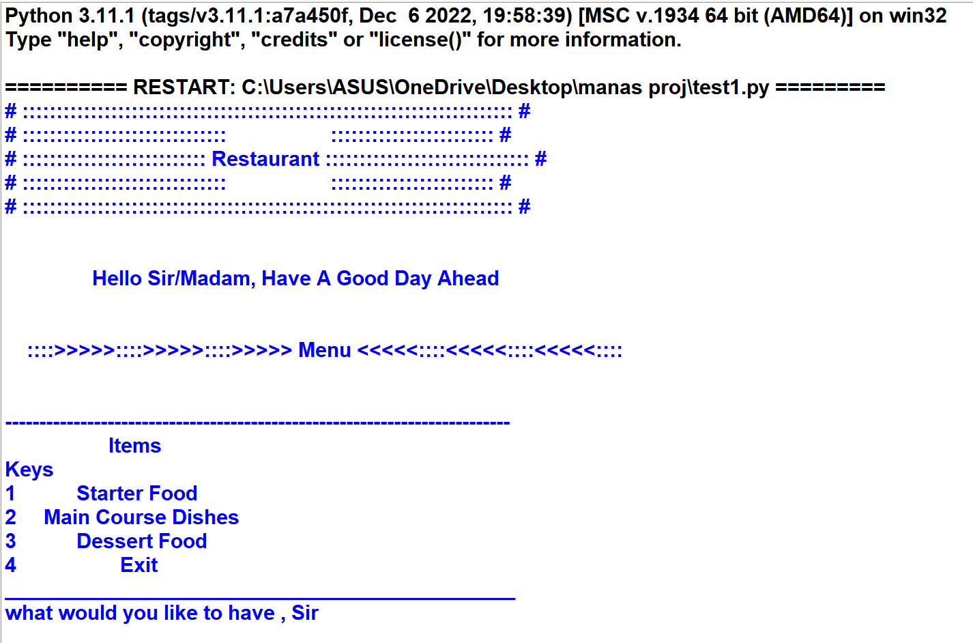

***STARTER***

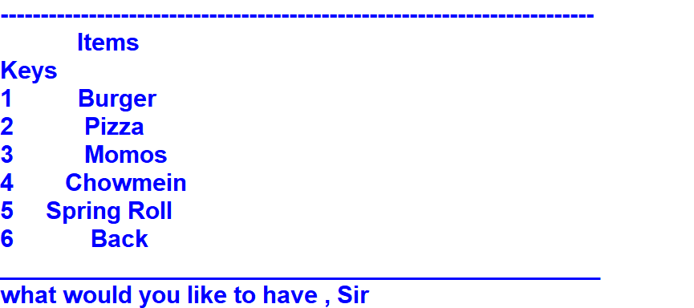

***BURGER***

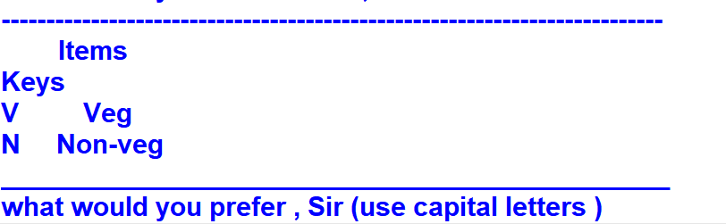

***VEG***

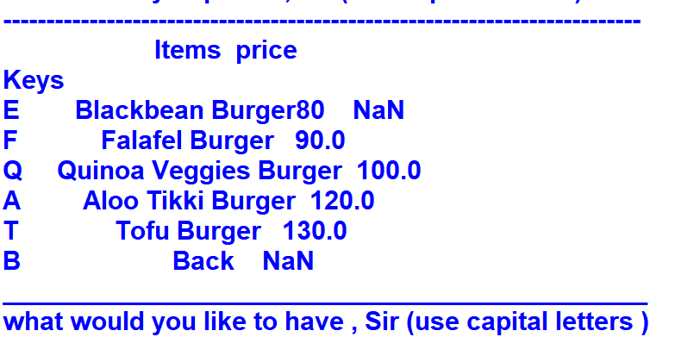

***NON-VEG***

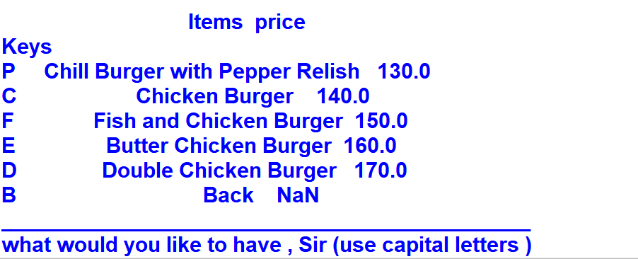

***PIZZA***

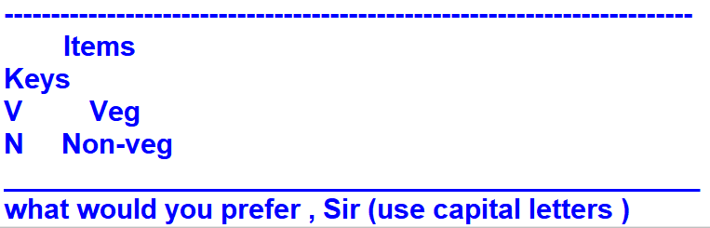

***VEG***

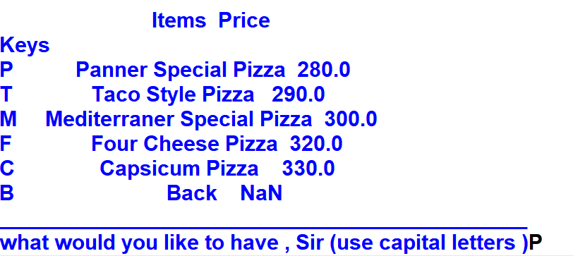

***NON-VEG***

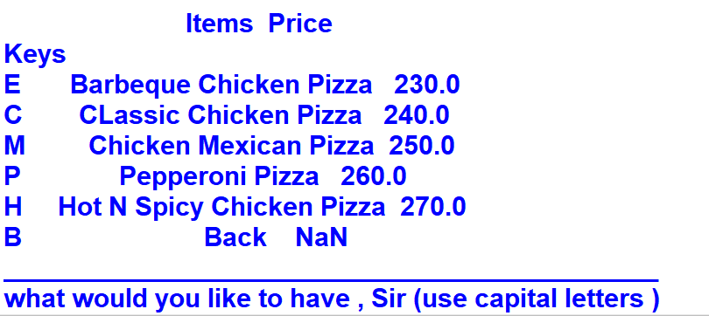

***MOMOS***



***VEG***

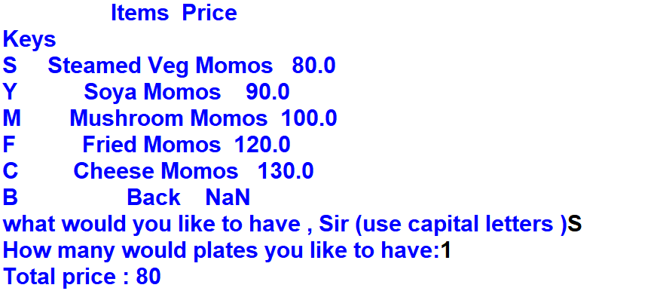

***NON-VEG***

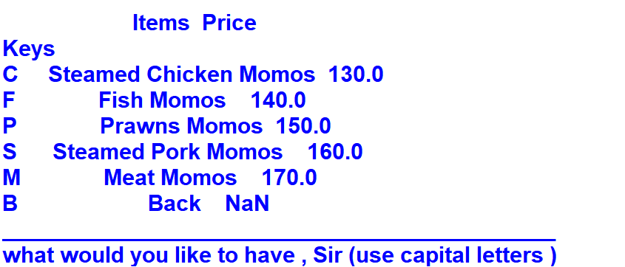

***Chowmein***



***VEG***

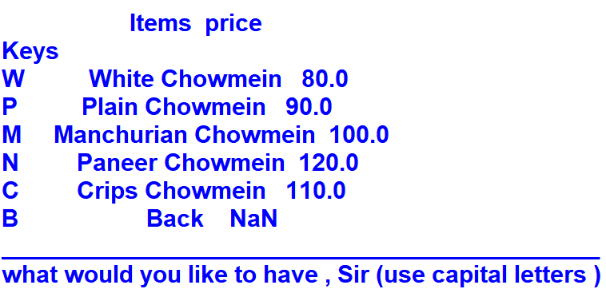

***NON-VEG***

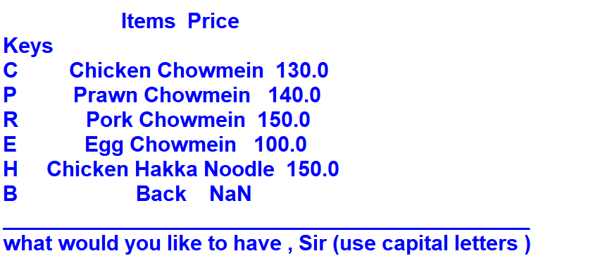

***SPRING ROLL***



***VEG***

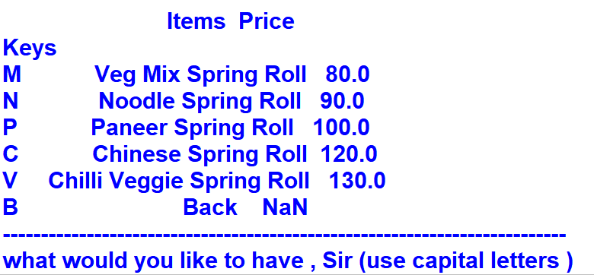

***NON-VEG***

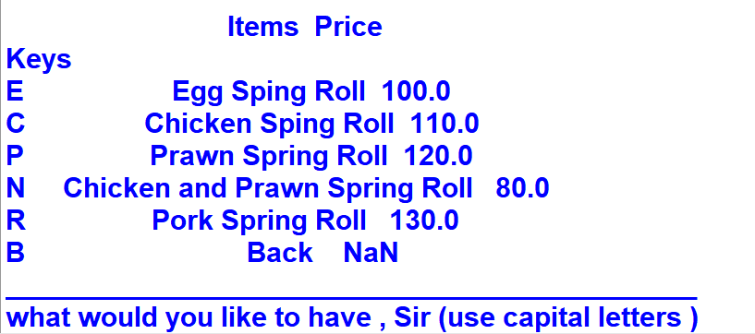

***Main Course Dishes***

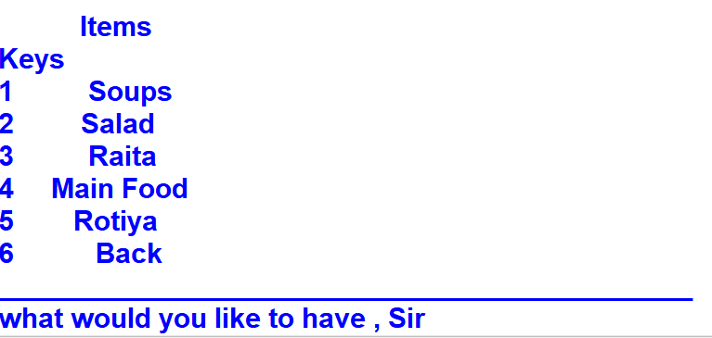

***SOUPS***



***VEG***

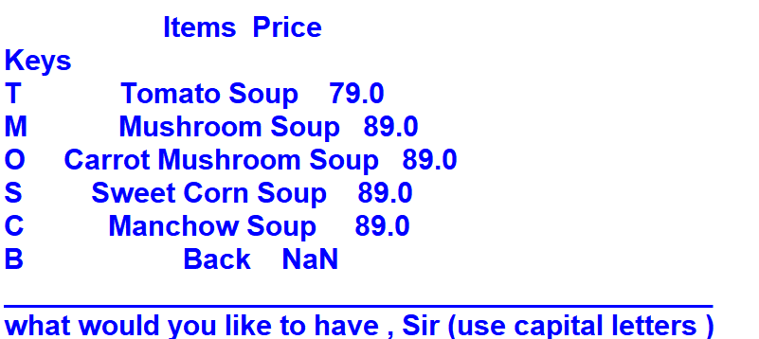

***NON-VEG***

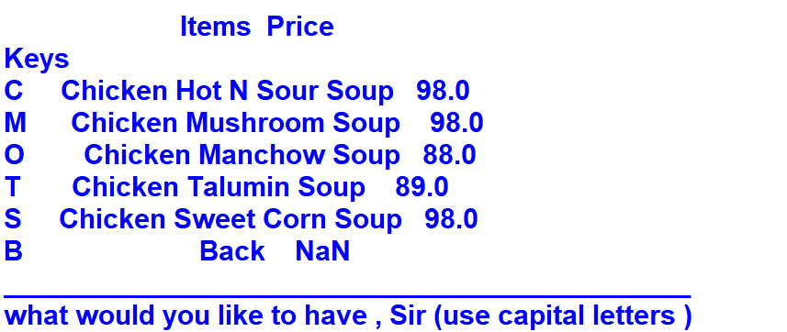

***SALAD***

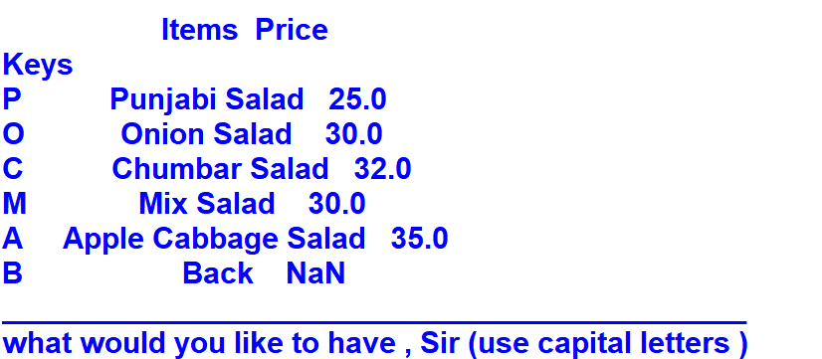

***RAITA***

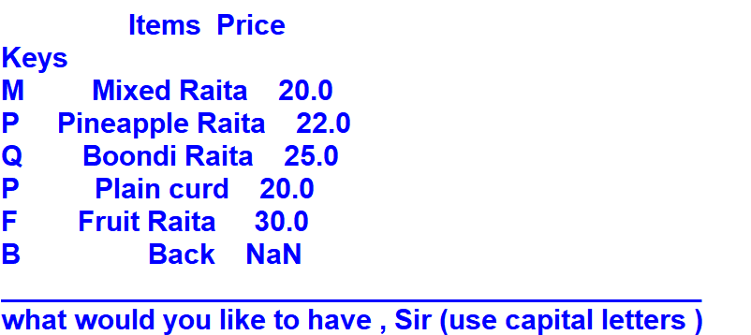

***Main Food***



***VEG***

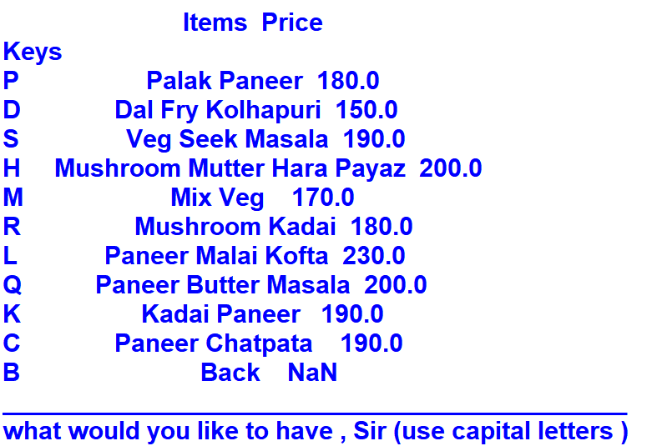

***NON-VEG***

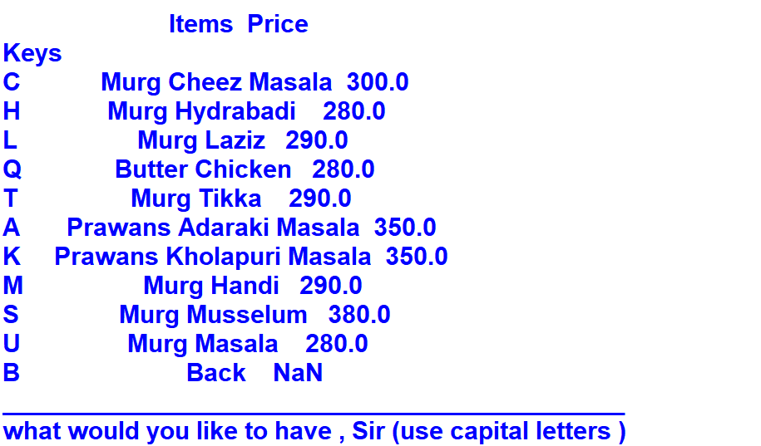

***Rotiya***

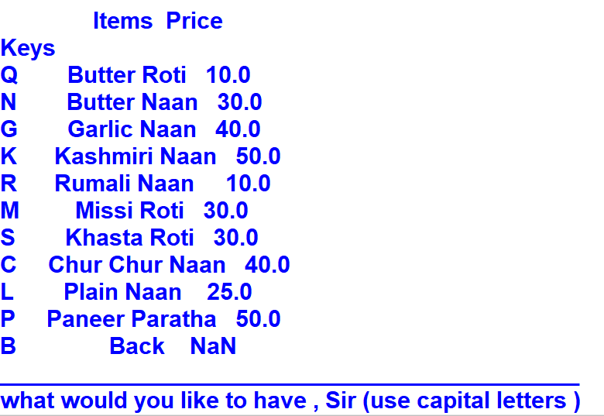

***Dessert Food***

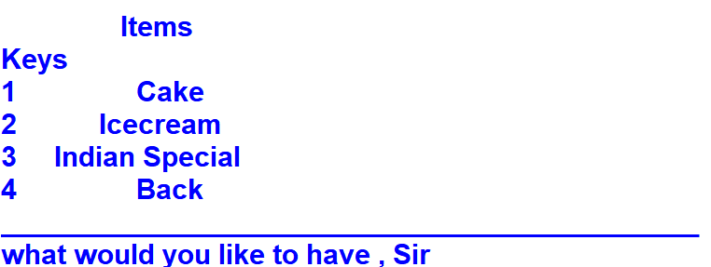

***CAKE***

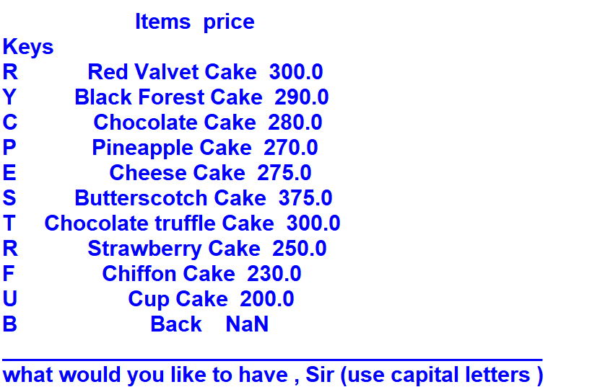

***ICECREAM***

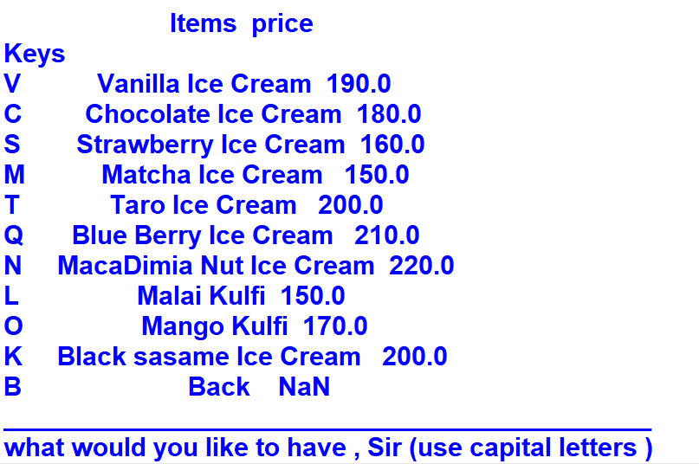

***INDIAN SPECIAL***

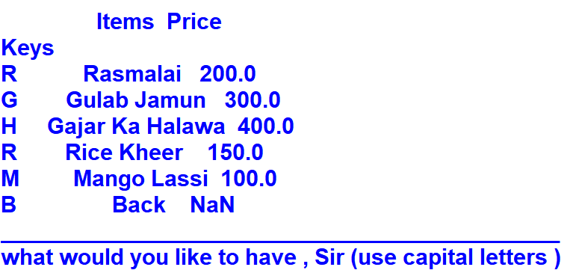

***BILL***

